Grad2Teach – NCFE Level 4 Teaching Fundamentals
Independent Learning Journal W11:
Reflection on formative assessment and how to use it effectively

Trainee Name: |  | Week Number: | 11
Date: |  | Focus Topic: | Formative Assessment

Top Tips for Using This Journal
- Write in clear, short sentences.
- Keep paragraphing focused and remember your topic sentences (a sentence that expresses the main idea of the paragraph in which it occurs).
- Avoid jargon unless you explain it.
- Keep it confidential – no full student names.
- In academic writing, reflection is the process of deeply analysing past experiences, events, or ideas to understand what happened, why, and how it has impacted your learning and future actions. It involves moving beyond simple description to critically evaluate strengths, weaknesses, and implications, often using academic models or theories to provide structure and depth to your insights. This is a really important skill for teachers.
- Declare any use of ChatGPT/AI if you have used it to help you complete the task* (*You will need to complete the AI Use Declaration Form and upload it if you have)
- Remember to keep within the word count. This document should be 500-750 words.
Brief for this journal: Complete a reflection on formative assessment and how to use it effectively in your planning and teaching.

ILJ – reflection on formative assessment strategies (500-750 words) | 1.2 Examine the school policies and procedures required for their role and responsibilities in their placement school (AO1)  7.2 Develop their own practice as an educational practitioner by effectively responding to advice and feedback from colleagues and mentors (AO1) | 4.1 Examine two formative assessment strategies (AO2)  4.2 Analyse the importance of using formative assessment strategies to check for pupils’ learning

Reminders:
- Gibbs Reflective Cycle prompts are below as an aide memoire for your journal entry
- You shouldn’t exceed the word limit for this IJL so be selective about the topic/s you write about – don’t try to include everything!

1. Description – What happened?

2. Feelings – what were you thinking and feeling?

3. Evaluation: what was good and bad about the experience?

4. Analysis – what sense can you make of the situation?

5. Conclusion – what else could you have done?

6. Action plan – if it arose again, what would you do?

What is formative assessment and why is it such an important part of teaching and learning?
Here’s a reminder of the prompts that you were given as a springboard for your evaluation of two formative assessment strategies – there may be a series of points that you would like to raise and discuss in your learning journal instead.
- The importance of assessing pupils’ knowledge and understanding at an early point in the lesson – ‘Do Now’s for example, recaps, etc
- The importance of frequent checks on learning and frequent opportunities to practise using knowledge and skills
- How teachers encourage pupils to understand the learning goals and how to measure their success against them
- How questioning is used to open up discussion, address any misconceptions
and clarify the direction of learning
- Any interventions (individual, small group, whole class) used by the teacher to move learning forward.

Remember the 5 Principles of Formative Assessment work (Dyan Wiliam) that you studied during your recent face-to-face training. Were any of those principles used? How?

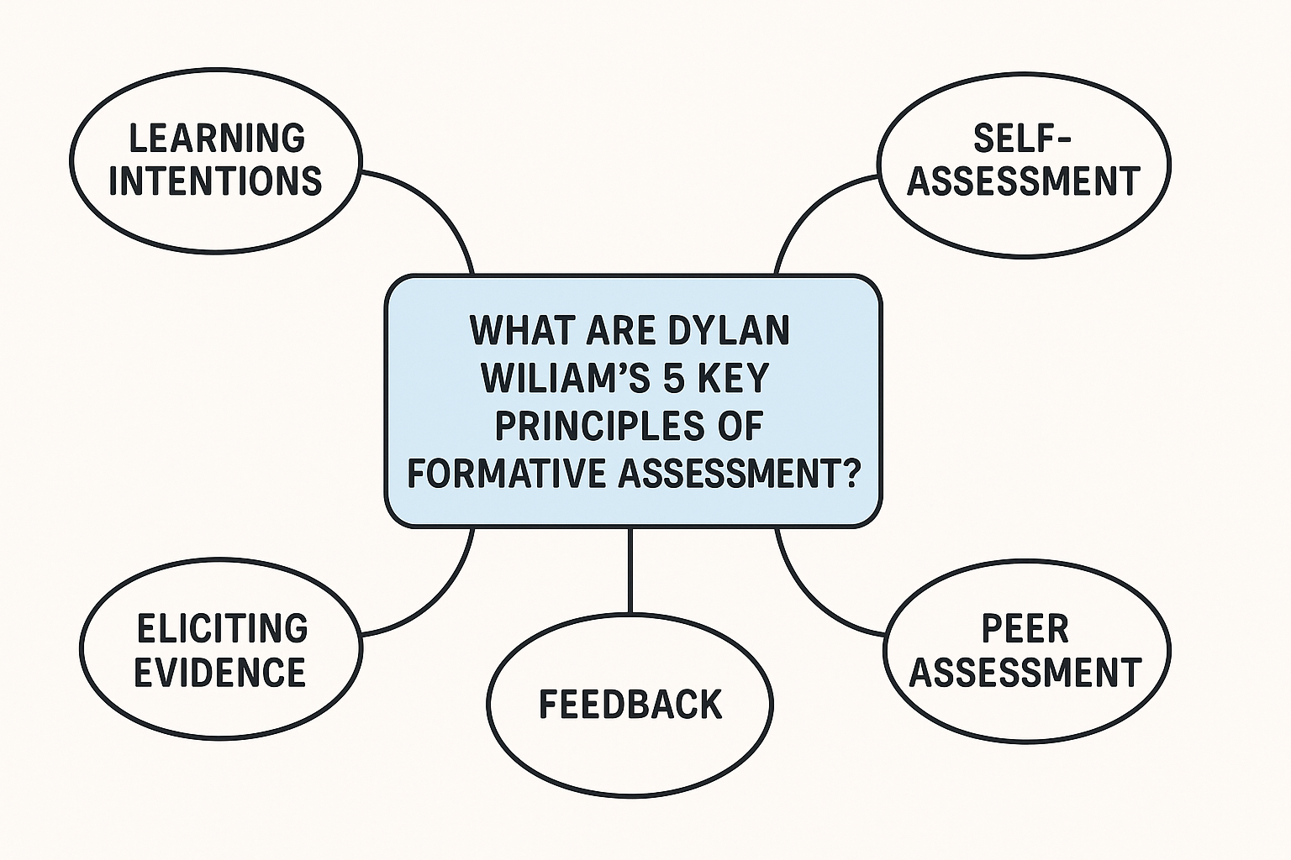

Click here to type...

