Grad2Teach – NCFE Level 4 Award in Teaching Fundamentals
Evaluation of 2 strategies I will take forward – Focus: Formative Assessment

Trainee Name: |  | Week Number: | 11
Date: |  | Focus Topic: | Evaluation of 2 strategies I will take forward – Focus: Formative Assessment

Top Tips for Using This Journal
- Write in clear, short sentences.
- Keep paragraphing focused and remember your topic sentences (a sentence that expresses the main idea of the paragraph in which it occurs).
- Avoid jargon unless you explain it.
- Keep it confidential – no full student names.
- In academic writing, reflection is the process of deeply analysing past experiences, events, or ideas to understand what happened, why, and how it has impacted your learning and future actions. It involves moving beyond simple description to critically evaluate strengths, weaknesses, and implications, often using academic models or theories to provide structure and depth to your insights. This is a really important skill for teachers.
- Declare any use of ChatGPT/AI if you have used it to help you complete the task* (*You will need to complete the AI Use Declaration Form and upload it if you have)
- Remember to keep within the word count. This document should be 250-400 words.

Brief for this journal: Use the prompts below to reflect on what you have learnt from observing your colleague teach, what strategies you intend to incorporate into your own teaching and how you will implement them to ensure they are a success. See Assessment Objective information below.
Week 11:  Evaluation of assessment strategies from observation (250-400 words) | 7.3 Develop and reflect on their own practice as an educational practitioner by actively observing expert colleagues | 3.1 Examine the key features of a learning experience or lesson plan  4.1 Examine two formative assessment strategies (AO2)  4.2 Analyse the importance of using formative assessment strategies to check for pupils’ learning | 1.1 Develop the use of pedagogy and/or educational research to support points made when discussing teaching and learning (AO3)  1.2 Analyse pedagogy and/or educational research when discussing teaching and learning (AO3)  2.1 Extrapolate appropriate examples from their own placement school experience to support points made when discussing teaching and learning (AO3)  2.2 Analyse examples from their own placement school experience when discussing teaching and learning (AO3)

1 Introduction (1–2 sentences)

Briefly set the context. What was the lesson you observed – topic, class, learning objective, etc
Click here to type...

2. What You Learned

Here you should describe your key learnings from the session. Focus on 2 - 3 key formative assessment takeaways such as:
- The importance of assessing pupils’ knowledge and understanding at an early point in the lesson – ‘Do Now’s for example, recaps, etc
- The importance of frequent checks on learning and frequent opportunities to practise using knowledge and skills
- How teachers encourage pupils to understand the learning goals and how to measure their success against them
- How questioning is used to open up discussion, address any misconceptions
and clarify the direction of learning
- Any interventions (individual, small group, whole class) used by the teacher to move learning forward.

Remember the 5 Principles of Formative Assessment work (Dyan Wiliam) that you studied during your recent face-to-face training. Were any of those principles used? How?

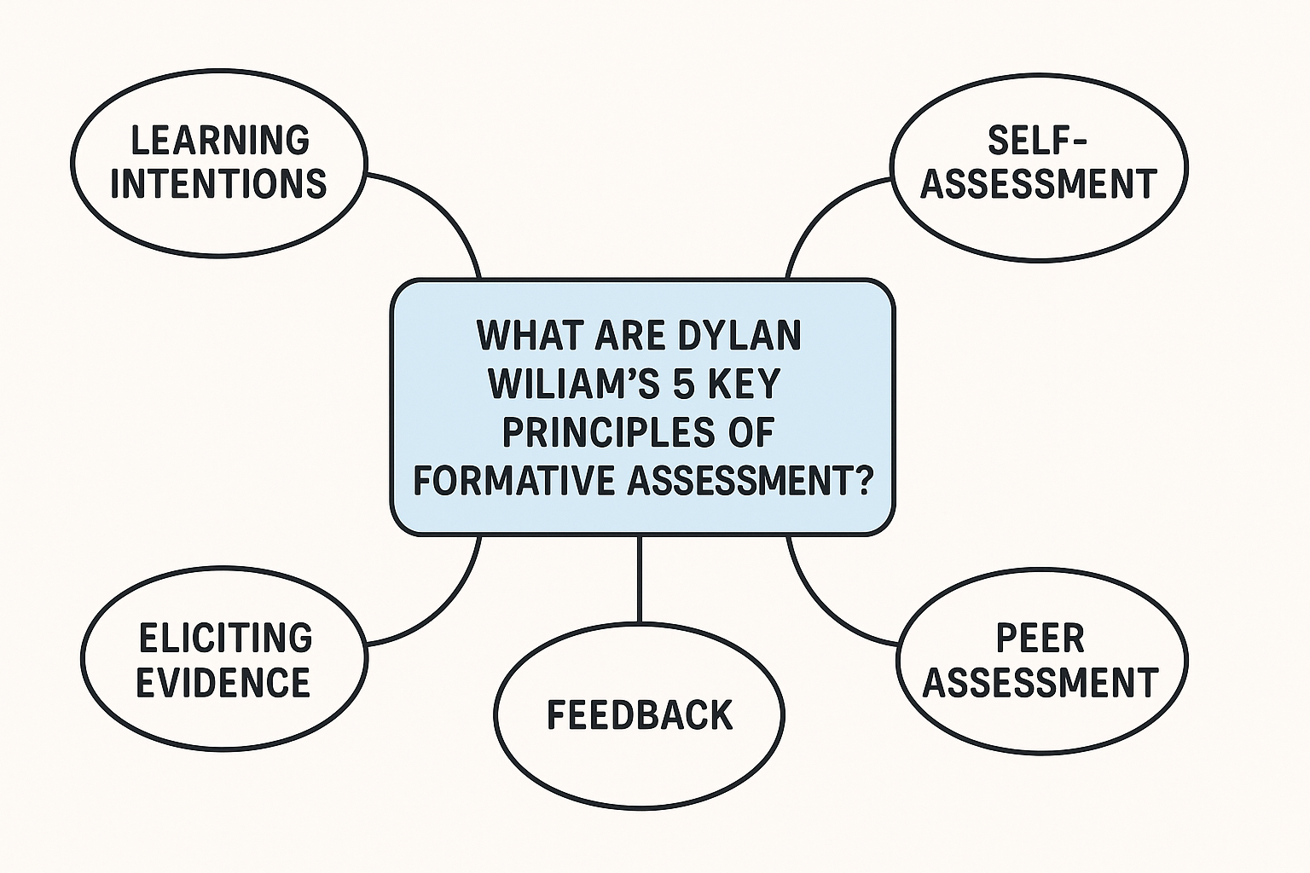
NB: Remember that this document should focus on no more than 2-3 strategies and that you can reserve your other ideas and reflections for your W11 Independent Learning Journal.

3. Personal Reflection & Application
Discuss how your 2 key takeaways have shaped your thinking or your approach as a trainee teacher:
- How do they apply to your future practice in the classroom?
- Have they challenged or affirmed your prior thinking?
- How do you intend to apply what you have learned? Identify positive elements:
Click here to type...

