Applied Teaching Practices Study Group 2: Inclusive & Adaptive Teaching
KEY NOTES
Thursday 5th February

Session Purpose and Overview
This study group built directly on Study Group 1: Inclusive Learning Environments and focused on how inclusive values are enacted through adaptive teaching practices in day-to-day classroom teaching.
The session was designed to:
- Develop trainees’ understanding of what inclusive teaching looks like in practice
- Clarify the distinction between differentiation and adaptive teaching, and why the profession has moved towards adaptive approaches
- Explore how adaptive teaching supports high expectations for all pupils, rather than lowering challenge
- Strengthen trainees’ ability to articulate inclusive practice for:
  - Learning Journals
  - Observation of Colleagues (OC)
  - Applied written assessments especially the AO2 Essay
  - AOR application and interview, PGCE, and PGTA interviews
April emphasised that:
- Engagement in discussion is a valid and valuable form of professional learning
- Trainees do not need to have completed all preparatory reading to contribute meaningfully
- The study group content is deliberately sequenced to build towards later assessments and professional conversations and is linked to the previous study group which focused on the importance of creating inclusive learning environments

Assessment Objective and Standards Links
This session primarily supports:
- Assessment Objective 2 (AO2): Professional Skills
- Teacher Standard 5: Adapt teaching to respond to the strengths and needs of all pupils
April clarified that:
- While differentiation remains referenced within the Teachers’ Standards (sub-standard 1 in TS5), the overarching expectation is now adaptive teaching
- Adaptive teaching reflects current educational thinking around inclusion, equality, and high expectations
- The language shift is intentional and rooted in concerns about how differentiation has sometimes been misapplied in practice

Part 1: Differentiation vs Adaptive Teaching
Understanding the Terminology Shift
April explored why the profession has moved away from a heavy reliance on differentiation towards adaptive teaching.
Differentiation (traditional interpretation):
- Ofsted and DfE refer to differentiation as “the provision of different types or levels of activities for different pupils or groups of pupils”
- Often organised through fixed groupings such as:
  - Low / middle / high achievers
  - Colour-coded or tiered tasks
- Typically planned before the lesson and applied rigidly

Adaptive Teaching (current emphasis):
- Teaching a shared learning objective to all pupils
- Planning for flexibility and responsiveness within the lesson
- Adapting explanations, questioning, scaffolding, and support in response to pupils’ needs
- Avoiding pre-judgements about pupils’ ability or potential
- All pupils now have access to the same curriculum, content and activities

Why Differentiation Can Be Limiting
Through discussion, trainees identified several risks associated with traditional differentiation models:
- Pupils may be labelled as “low ability” or “high ability”, reinforcing fixed perceptions of capability
- Tasks designed for lower achiever groups may unintentionally reduce challenge and aspiration
- Pupils can internalise expectations placed upon them, leading to a self-fulfilling prophecy
- Fixed groupings limit opportunities for pupils to access higher-level thinking and learning
April summarised this clearly, noting that:
“Differentiation can unintentionally place a glass ceiling on pupils’ achievement.”

Fixed Mindset and Growth Mindset
The discussion naturally linked adaptive teaching to Carol Dweck’s theory of mindset.
Fixed mindset characteristics:
- Pupils believe intelligence and ability are innate and unchangeable
- Labels such as “low ability” become embedded in pupils’ self-perception
- Pupils may avoid challenge to protect their sense of competence
- Mistakes are viewed as failure rather than learning opportunities
Growth mindset characteristics:
- Pupils understand that ability develops through effort, practice, persistence, learning and feedback
- Challenge is viewed as a necessary part of learning
- Mistakes are accepted as a normal and valuable part of the learning process
- Pupils demonstrate greater resilience and perseverance
April emphasised that:
- Adaptive teaching actively supports the development of a growth mindset
- Inclusive classrooms must avoid practices that reinforce fixed ability labels
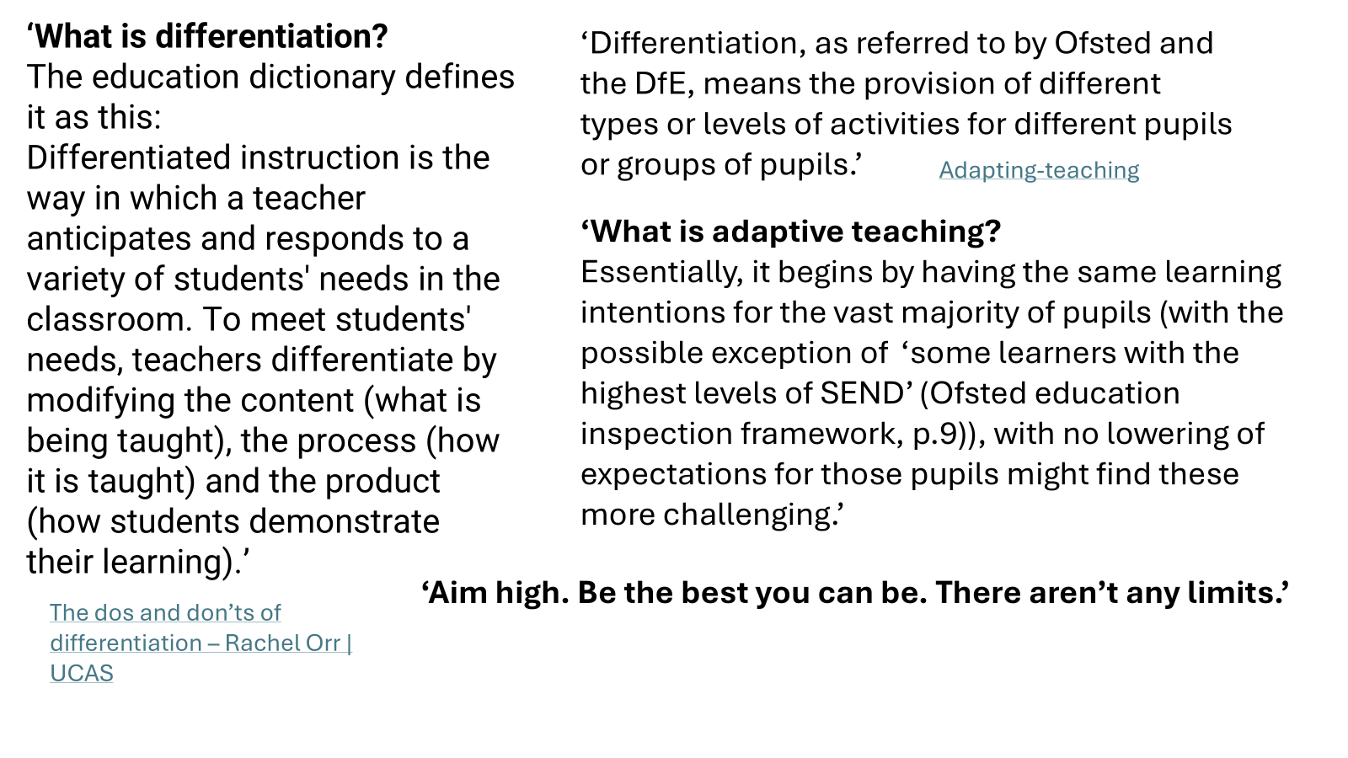
Mixed Ability Teaching and Setting
The group explored the implications of mixed ability teaching, particularly in comparison to setted classes in secondary schools.
Key discussion points included:
- Mixed ability classes:
  - Encourage peer learning and collaboration
  - Allow pupils with different strengths to support one another
  - Reduce the risk of limiting pupils based on narrow attainment measures
- Even within setted classes, ability remains diverse and complex
- Decisions around setting are often shaped by:
  - School leadership and trust-level policies
  - Subject-specific traditions, particularly in core subjects
April highlighted that:
- There is no universally “correct” approach
- Adaptive teaching is essential regardless of grouping structure

Part 2: Adaptive Teaching Strategies in Practice
Trainees shared a range of adaptive strategies observed or used within their classrooms.
Assessment for Learning (AfL)
Effective AfL strategies discussed included:
- Targeted questioning to involve all pupils, rather than relying on volunteers
- Mini whiteboards to assess whole-class understanding in real time
- “Do Now” activities to activate prior knowledge and settle pupils quickly
- Exit tickets to identify misconceptions and inform future planning
- Live modelling and re-modelling to address misunderstandings immediately
Targeted Support and Inclusion
Examples of inclusive adaptive practice included:
- Providing pupils with reassurance before asking them to contribute verbally
- Prioritising pupils who may lack confidence when directing questions after checking their work is accurate when moving around the room during activities (especially good for SEND pupils) to increase their confidence
- Offering additional resources discreetly, allowing pupils to choose support without stigma
- Adapting explanations or prompts rather than producing multiple worksheets
Active and Engaging Learning Approaches
Trainees highlighted strategies that increased engagement and inclusion, such as:
- Structured debates linked to real-world issues (e.g. ethical discussions around AI)
- Paired and group discussion to support verbal reasoning
- Role play and discussion-based tasks to deepen understanding
Primary-Specific Adaptive Strategies
Primary colleagues shared examples including:
- Sentence starters to scaffold writing
- Visual prompts and images to stimulate ideas and support comprehension
- Allowing pupils to demonstrate understanding through drawing or practical work
- Use of concrete resources in mathematics
- Photographing practical outcomes as valid evidence of learning
April noted that these strategies are equally valuable in secondary contexts.

Chunking and Cognitive Load
The group explored why breaking learning into manageable chunks supports inclusive practice.
Key points included:
- Working memory has a limited capacity of around 7 ± 2 items or only a handful of chunks
- Large volumes of information can overwhelm pupils
- Chunking allows teachers to:
  - Monitor understanding before moving on
  - Adjust pace responsively
  - Reduce cognitive overload
This approach supports:
- Inclusive classroom practice
- Adaptive pacing
- Long-term retention through retrieval and rehearsal (Multi-Store Memory Model: Atkinson and Shiffrin)

Pupil Autonomy and Metacognition
April introduced pupil autonomy as a central feature of adaptive teaching.
Developing Pupil Autonomy
Pupil autonomy involves:
- Pupils taking increasing responsibility for their learning
- Teachers providing structured choices in how learning is approached
- Scaffolded independence rather than unstructured discovery
Examples included:
- Allowing pupils to choose how they demonstrate learning (written, visual, verbal)
- Guided discovery learning supported by clear success criteria
- Encouraging pupils to reflect on what strategies work best for them
Understanding Metacognition
Metacognition was defined as:
“Thinking about one’s own thinking” John Flavell (1979)
Key elements include:
- Planning how they want to approach a task
- Monitoring their own understanding during learning
- Evaluating their success and reflecting on their progress after completion
- Adapting strategies for future tasks
April stressed that:
- Metacognition should be introduced gradually
- It benefits pupils of all ages when carefully planned and scaffolded by teachers

Whole-School Approach to Adaptive Teaching
April shared an example from Purbrook Park School, showing a coherent whole-school approach.
Key features included:
- Teaching to the top with high expectations for all pupils
- Use of scaffolding to ensure accessibility
- Focus on the whole class
- Focus on adaptive teaching and metacognition
- Emphasis on:
  - Assessment for Learning
  - Verbal feedback
  - Chunked curriculum delivery
Staff Responsibilities
Staff are expected to:
- Plan for adaptive teaching within lessons
- Use questioning and feedback to support inclusion
- Monitor pupil understanding continuously
- Create emotionally safe learning environments
- Plan “Think Hard” and “High Challenge” activities

Pupil Responsibilities
Pupils are encouraged to:
- Engage actively with learning
- Use feedback to improve
- Reflect on their progress
- Develop confidence and resilience
- All of these are part of metacognition
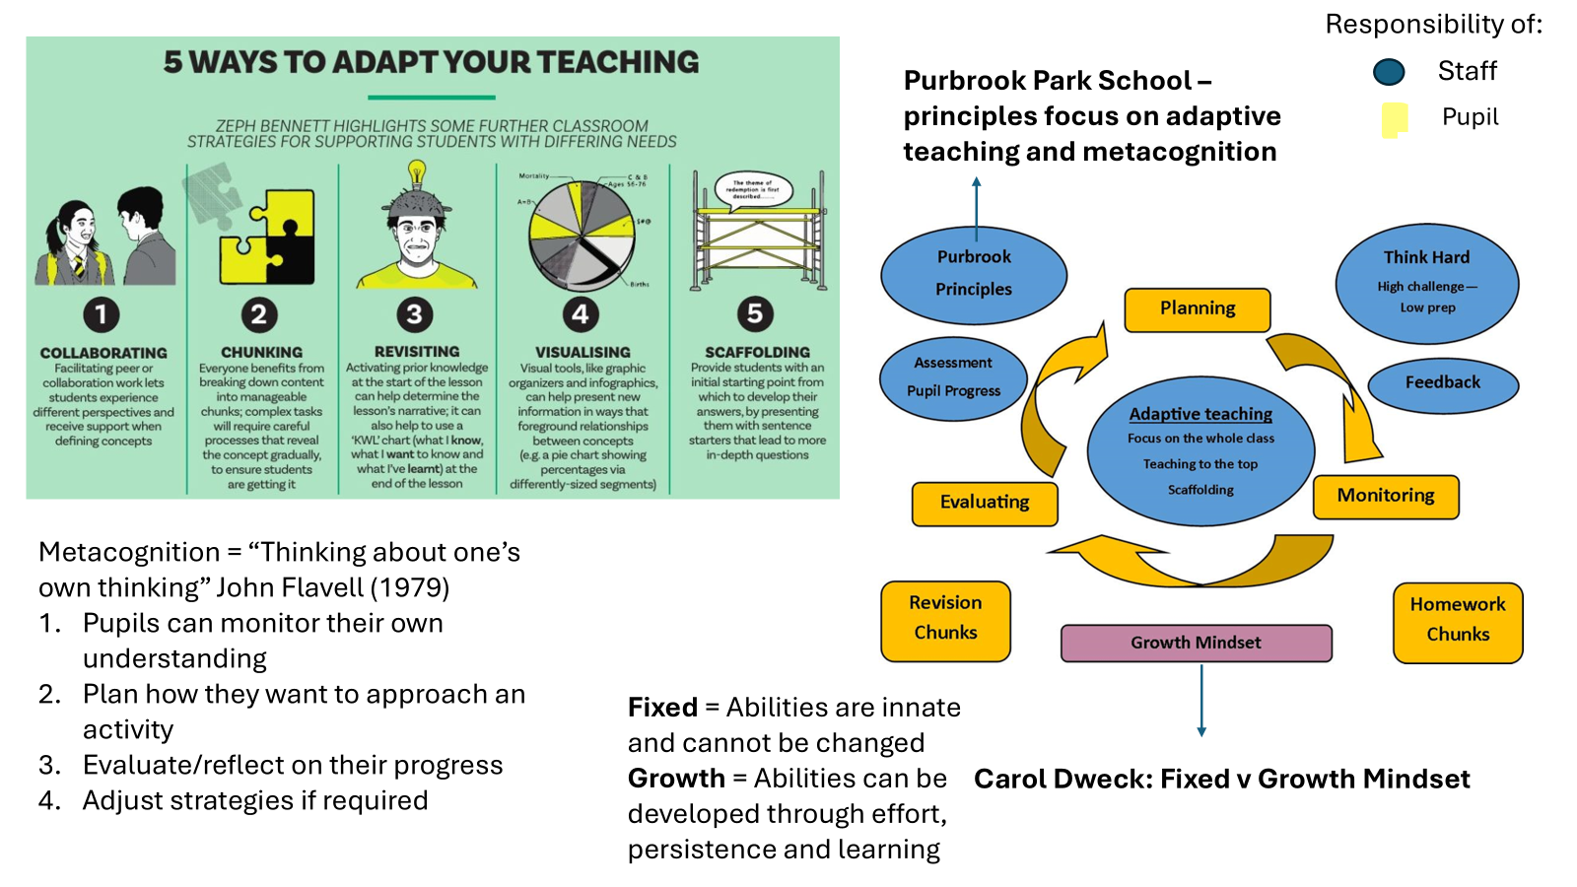

Verbal Feedback and Responsiveness
April highlighted the importance of verbal feedback as a key adaptive strategy.
Effective verbal feedback:
- Occurs in the moment
- Is specific and actionable
- Allows pupils to respond immediately
- Reduces reliance on written marking
This approach supports:
- Inclusion
- Pupil confidence
- Continuous improvement

Links to Assessment and Professional Applications
April made explicit links between the session content and:
- The Applied AO2 written assignment
- Observation of Colleagues tasks
- AOR application and interview preparation
- PGCE and PGTA applications

Trainees were reminded that:
- OC2 Observation of Colleagues should focus on inclusive and adaptive strategies
- Learning Journals should draw directly on study group discussions
- All professional engagement in Study Groups and Training Day 2 (TD2) contributes to assessment evidence as the course is Holistic
April introduced the AO2 Essay, which will give trainees supporting evidence for the majority of the AO2 assessment criteria. She emphasised that all the trainees AO2 ILJ’s are linked to the essay and provide notes to support their understanding of inclusive teaching and learning environments.
The AO2 Essay will be part of TD2, and detailed supporting documents are already on the Trainee Hub under Study Group 2.
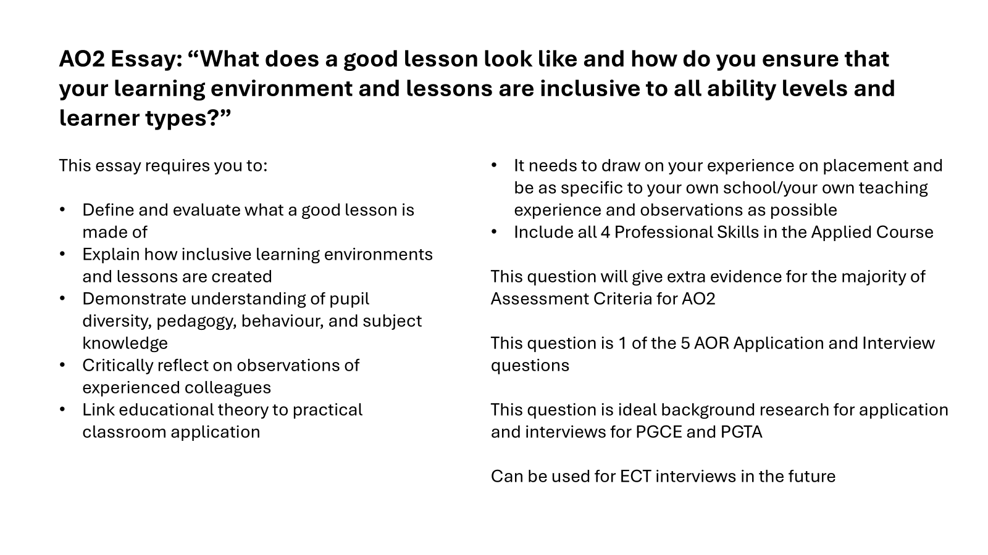
Professional Development and Wider School Contribution
April introduced the School Community / Professional Project, clarifying expectations.
More detailed information can be found on the Trainee Hub under Study Group 2.
Key points included:
- Projects do not need to be new or large-scale
- Trainees may contribute to existing initiatives such as:
  - Assemblies
  - Extracurricular clubs
  - Breakfast clubs
  - Mentoring and wellbeing initiatives
  - Trips, enrichment days, or interventions
The focus is on:
- Professional learning
- Reflection on impact
- Developing a broader understanding of school life
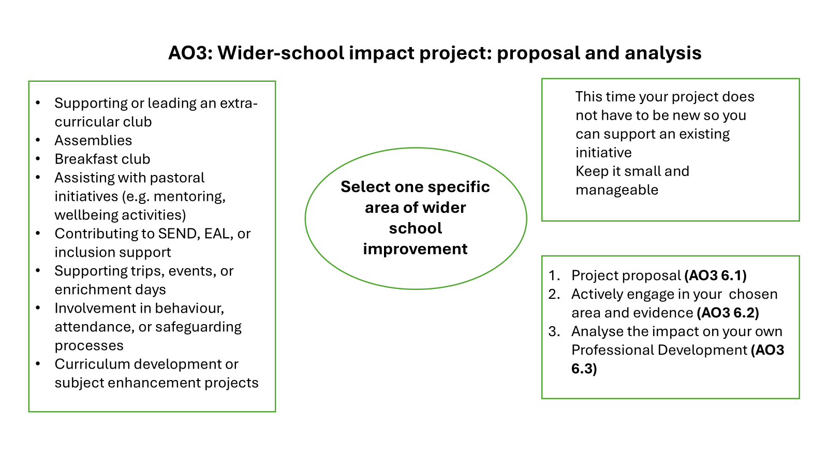
Key Takeaway Messages
- Adaptive teaching supports inclusion without lowering expectations
- Labelling pupils' limits confidence, aspiration, and progress
- Growth mindset is central to inclusive classroom practice
- Small, responsive adaptations can have significant impact
- Professional learning is cumulative and interconnected
- Inclusive teaching requires belief in the potential of all learners

These key notes support Learning Journals, Applied essays, Observation of Colleagues tasks, and professional interview preparation.

